Cognitive Transitions in Care
The Importance of Working Memory Exercise Prescription

When healthcare practitioners use BCAT® Test System results to identify candidates for cognitive interventions and they prescribe working memory exercises (WME) as part of the discharge plan of care, their clients achieve both immediate and long term, sustainable improvements in key skills such as attention, memory and executive function.
Active participation in evidenced-based cognitive exercises post discharge from therapy is essential to sustain the cognitive gains and to mitigate against further decline.

Healthcare professionals should do the following:

Step 1: Administer the BCAT®.
- Utilize the BCAT® Test Scores to prescribe an individualized cognitive exercise program for individuals to use post discharge from services. See additional information on page 2 and the crosswalk on page 3 of this packet to provide specific prescriptive recommendations.

Step 2: Based on BCAT® Scores:
- Patients/clients that score ___ provide clients, family members and/or caregivers with page ___. Provide education on the importance of completing working memory exercises.
- Patients/clients that score ___ provide clients, family members and/or caregivers with page __. Provide education on the importance of cognitive stimulation and meaningful engagement.

Additional information for the healthcare professional on the benefits of WME:
Persons with BCAT® Test scores that are consistent with Mild Cognitive Impairment (MCI) have a meaningful, 2-point improvement from initial BCAT® score to a secondary BCAT® Test administration when using our WME program during their plan of care. Additionally, those who were prescribed ongoing WME completion post-discharge as part of a home program demonstrated sustainability of these improvements up to 1 year after services ended. Sustainable gains in cognition translate into maintaining independence and the ability to age in place successfully. Persons who did not participate in WME have a decline of 6 points.
MCI Group | Initial BCAT® Test Score | BCAT® Test Score: 6 month | BCAT® Test Score: 12 month
Participated in WME exercises | 39 | 41 | 41
No cognitive exercises | 39 | 36 | 35

Similar findings were also present in the sample of participants with BCAT® Test Scores consistent with mild dementia. When this population participated in comprehensive assessment, WME exercises, and were prescribed and participated in a WME cognitive home program, they also achieved both immediate improvement and maintained those gains with stable and sustainable cognitive and functional skills for up to 12 months. Decline without exercises in points.
Mild Dementia Group | Initial BCAT® Test Score | BCAT® Test Score: 6 months | BCAT® Test Score: 12 months
Participated in WME Exercises | 29 | 31 | 31
No WME Exercises | 29 | 28 | 26

Crosswalk for the healthcare professionals:
Use the table below to prescribe a cognitive home program. Items in bold have the most research surrounding the benefits of targeting working memory. Provide your client/patient wi
Cognitive Stage | BCAT® Test Scores | Resources
Clients/patients that score in the blue range, provide them with pages 4 and 5 of this packet.
- Normal aging  - Mild Cognitive Impairment (MCI)  - Mild impairment and/or dementia | BCAT® Total Score of 25-50 | - The BCAT® Working Memory Exercise Book - Home Edition  - Digital Working Memory Exercises  - The BrainSharpTM Exercise Book  - The BCAT® Brain Fitness Book – Volume 1  - ENRICH® Brain Health Program – Brain Exercise of the Week  - Family Matters  - 15 For Me®
Clients/patients that score in the red range, provide them with pages 6 and 7 of this packet.
- Moderate impairment and/or dementia  - Severe impairment and/or dementia | BCAT® Total Score of 0-24 | - MemPics® Book Series (13 different topics are available)  - The Dementia Journey: A Navigation Manual for Family Members  - Family Matters  - 15 For Me®

The Benefits of a Prescribed Brain Health Program: Maintaining Your Independence
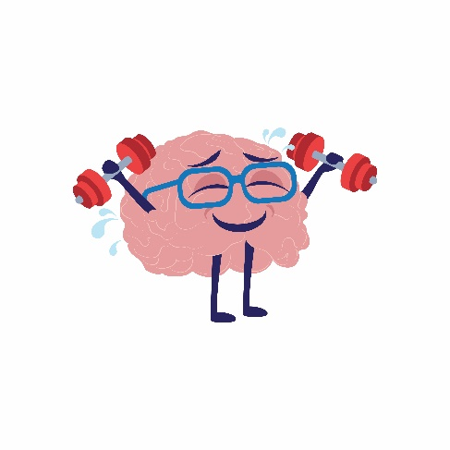
For older adults, cognition should be considered a “vital sign.” Vital signs are measurements of the body’s basic functions and are vital for healthy functioning. Cognition is at the center of everything we do and is essential for us to successfully perform everyday tasks. It consists of multiple domains, including attention, memory (e.g., remembering to take medications, remembering a doctor’s appointment), and executive functions (e.g., judgment, problem-solving, reasoning).
Healthcare practitioners often use assessment tools to identify the presence and/or the severity of changes in these skill areas and recommend interventions to target these issues. By regularly completing cognitive exercises, you can increase your ability to maintain these skills immediately and up to a year.
How do Cognitive Exercises Work?
- Improve “working memory” or the ability to hold and use information which can result in improved memory.
- Strengthen the brain’s defenses and buffer against decline.
- Promote the ability to live independently for as long as possible.
What People Are Saying About Participating in Cognitive Exercises?
- 85% of participants credit the cognitive exercises for improving their cognition.
- 92% of participants reported overall satisfaction with cognitive exercises.
Get Started Today!
The BCAT® Research Center offers two different resources to complete scientifically validated working memory exercises. You can complete workbook activities or use an online platform to maintain your cognition now and in the future.
Complete exercises 5x/week for 15 min a day for best results using the resource(s) selected below.


BCAT® Working Memory Exercise Book – Home Edition – basic and more advanced cognitive exercises that can be completed as part of a home program. Hours of paper/pencil activities that promote neural plasticity and cognitive reserve are included.

Digital Working Memory Exercise Platform – online interactive cognitive exercises that target memory, attention, and organization skills. These exercises offer different levels of difficulty, with something for everyone.

Cognitive Exercises to improve your Brain Health
Book / Program Description | Link to Access
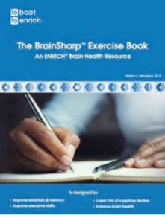  The BrainSharp™ Exercise Book ($19.95):  Adults use this book as part of a cognitive “workout routine” to improve cognitive performance and everyday functioning. This book contains three specific exercise types: mazes, word scrambles, and word searches. | 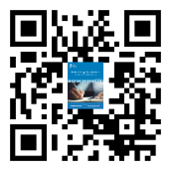  https://enrichvisits.com/shop/the-brainsharp-exercise-book  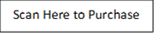

The BCAT® Brain Fitness Book
Offers basic and complex online cognitive exercises used to promote positive cognitive functioning and buffer against decline. These interactive digital exercises target the thinking skills needed to maintain independence.

15 For Me®
ENRICH® Brain Health Program (FREE):    Free, scientifically validated set of tools that supports the identification of mood and/or cognitive changes, provides brain health education, and offers a variety of tools to support the sustainability of cognitive functioning for persons across the cognitive continuum. | www.enrichvisits.com

Based on BCAT score, your healthcare provider suggests that you participate in the following

Book / Program Description | Link to Access
  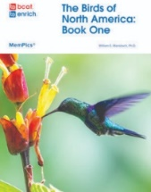        MemPics® Book Series ($16.95 per book):  These books activate memories through pictures and conversations about familiar people, places, objects, and events. Clinicians prescribe MemPics® books to offer persons with memory loss a variety of cognitively enhancing activities that provide opportunities for meaningful engagement with family members and/or caregivers. There are 13 different topics available. | https://enrichvisits.com/individuals-family-members-bookstore    Scan Here to Purchase
Family Matters Interview Series (FREE):    Designed to inform and support family members with loved ones who have cognitive impairment and/or dementia. These free monthly programs are 30 minutes in length and include an expert from the BCAT® Research Center, or other expert healthcare professional, being interviewed about specific topics via a virtual format. | https://www.youtube.com/playlist?list=PLl5n0y3KJhMbqJmamejEhbpa0rVqp61al

